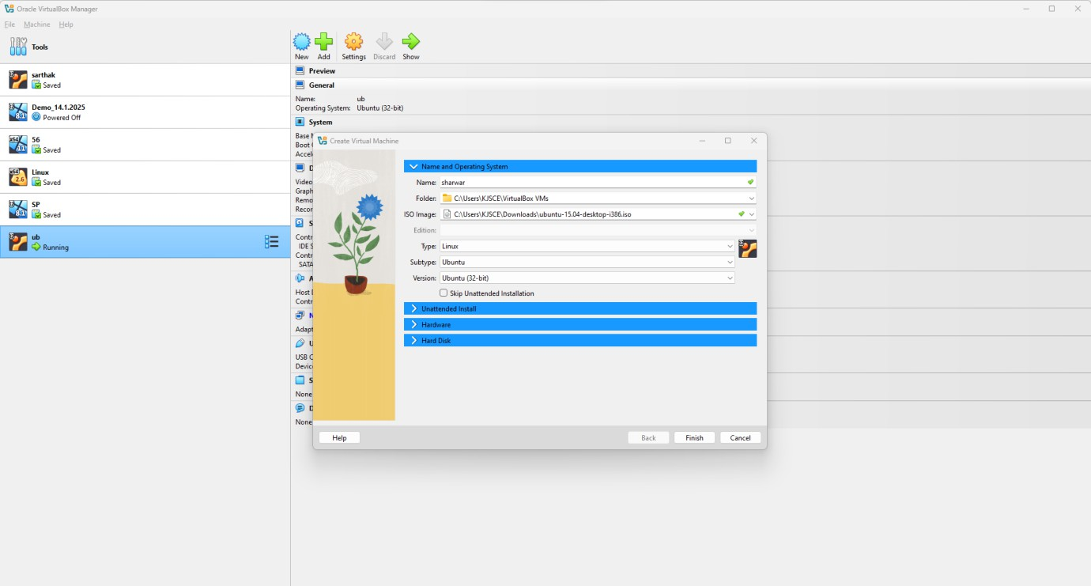Set Up File Sharing Between Host and VM

# Using VirtualBox:

1. **Install Guest Additions (for Linux or Windows VM):**
   * 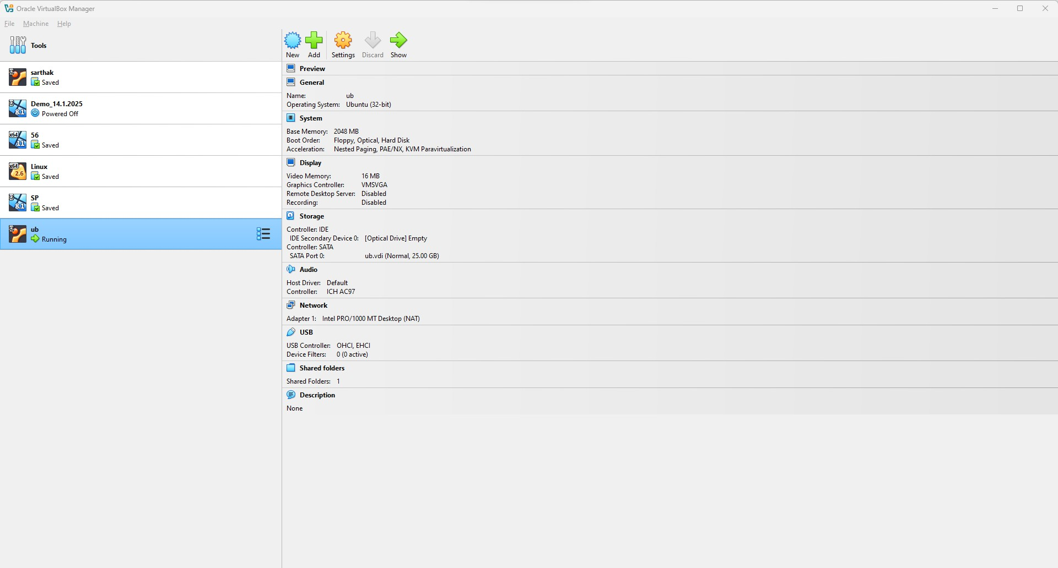Start the VM already installed. / Restart the VM after installation.

# C:\Users\KJSCE\Pictures\Screenshots\Screenshot 2025-01-15 142848.pngEnable Shared Folders:

* + Click on the VM in VirtualBox and go to Settings > Shared Folders.
  + Click the + icon to add a folder.
  + Choose a folder on your host machine to share and specify:
    - **Folder Path:** Path to the folder on the host.
    - **Folder Name:** Name to access the folder in the VM.
    - **Read-only (optional):** Check this if you want the VM to only read the files.
    - **Auto-mount (recommended):** Automatically mount the shared folder when the VM starts.

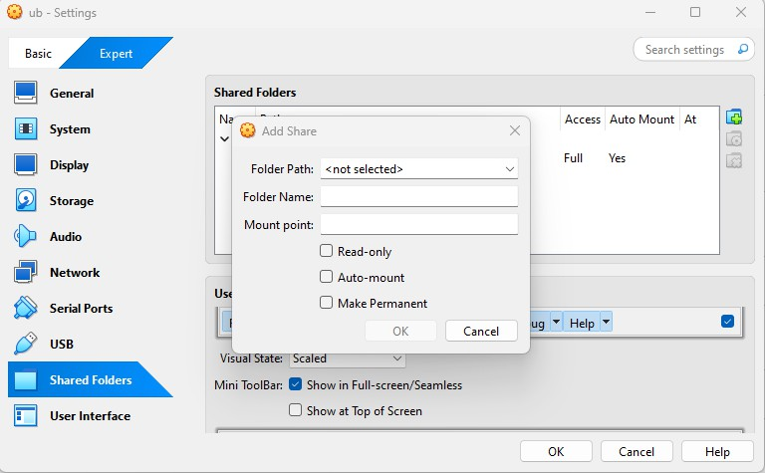



1. 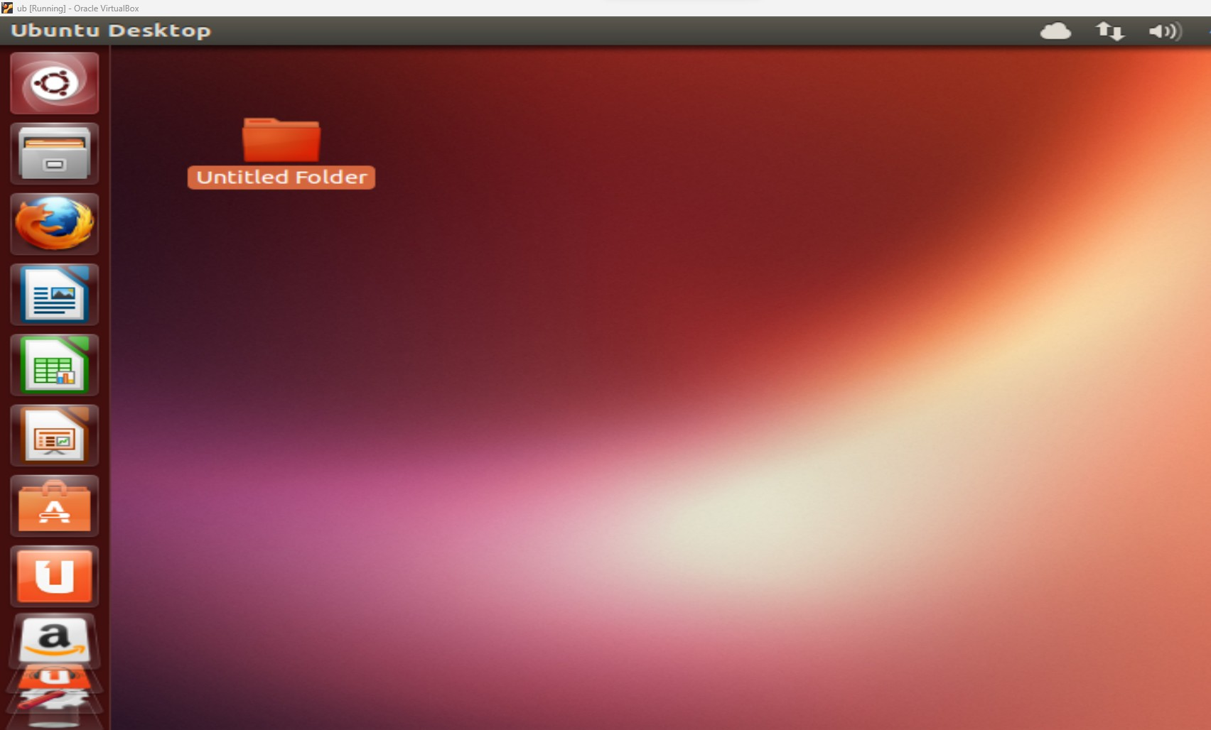**Ping Between VMs or From Host to VM:**

# Networking Mode Options:

* **NAT:** Host can ping VM, but VMs can't ping each other directly.
* **Bridged:** Host and VMs can communicate, and VMs can ping each other if they're on the same network.
* **Host-Only:** Only the host and VMs can communicate.

# Ping from Host to VM:

* 1. Find the VM's IP Address:

**ip addr show or ifconfig**

* 1. Ping the VM from the Host:

Open a terminal or command prompt on the host

**ping <VM_IP_Address>**

